|  |  |  |  |  |  |  |
| --- | --- | --- | --- | --- | --- | --- |
| **Practicum Final Exam – Odd Semester Year 2021/2022** | | | | | | |
| **Subject** | | | **COMP6153001 – Operating System** | | |  |
| **Class** | **:** | **BM01 / BN01** | | **Start Date** | **: 13 January 2022** |
| **Lecturer** | **:** | **D5104 - Dr. Robertus Nugroho Perwiro Atmojo, S.Kom., M.M.S.I, CSCA** | | **Start Time** | **: 07:20 WIB** |
| **End Date** | **: 13 January 2022** |
| **End Time** | **: 09:20 WIB** |

**PERATURAN UJIAN:**

*Exam Regulations:*

* Mahasiswa tidak diperbolehkan berdiskusi dan/atau bekerja sama dengan peserta ujian lainnya

*Student is not allowed to discuss and/or work together with other exam participants*

* Mahasiswa tidak diperbolehkan untuk membuka dan menyalin dari **BUKU** atau **CATATAN**, **VIDEO** dari pengajar (recording kelas, VBL, Youtube, dsb) dan **REFERENSI** lainnya

*Student isn't allowed to open and copy from any resources such as notes, videos (class recording, VBL, Youtube, etc) and other references*

* Mahasiswa tidak diperbolehkan membuka dan menyalin jawaban dari internet (google, stackoverflow, dsb)

*Student isn't allowed to open and copy answer from the internet (google, stackoverflow, etc)*

* Asisten **BERHAK** memberi nilai 0 **(NOL)** bagi peserta ujian yang melakukan segala bentuk kecurangan

*Assistant is able to give 0 (ZERO) score for exam participant who does any cheating actions*

* Kumpulkan jawaban tepat pada waktunya, apabila terlambat mengumpulkan maka jawaban tidak akan dikoreksi dan nilai mahasiswa adalah 0

*Submit the answer on time, if not, then the answer will not be checked, and the students will receive 0 (ZERO)*

* Bila Anda tidak membaca peraturan ini, maka Anda dianggap telah membaca dan menyetujuinya

*If you have missed to read these regulations, so you are considered to have read and agreed on it*



**SOFTWARE YANG DIGUNAKAN:**

*Software will be used:*

* Java 8
* Eclipse 2020.6
* NachOS 5.0j

**FILE YANG DIKUMPULKAN:**

*File must be collected:*

* JAVA
* CLASS

**PERHATIAN!**

*Attention!*

* Bagi yang mengerjakan tidak sesuai dengan soal, maka akan diberikan nilai **NOL (0)**

*For those who do not work in accordance with the exam case will be marked as* ***ZERO (0)***

* Bagi yang mengerjakan tidak sesuai dengan software dan versi yang telah ditetapkan, maka akan tetap dikoreksi dengan software dan versi yang telah ditetapkan

*For those who do not work in accordance with the software and specific version will be corrected by the predefined software and version*

* Kompres semua jawaban yang akan diunggah. Pastikan format pengumpulan nama file dan ekstensi sesuai dengan format berikut: **[NIM]-[NAMA].zip**

*Compress all file that will be uploaded. Make sure the format for collecting file name and extension according to the following format:* ***[NIM]-[NAME].zip***

**Important Notes**:

1. Use your **own Console** and **Scheduler (LIFO)**.
2. Youmustuse **Semaphore** to **control** operation.
3. You must use **Timer** to generate tick of time.
4. You must use **File System** to save the data.
5. Use **KThread**.

**Soal**

*Case*

**Blacksmith**

**Blacksmith** is a system that saves weapon data which have been created by the blacksmith. You as a programmer are asked to make a program for **Blacksmith admin**. As they are still new in this industry, their first goal is to create a dependable storage system using **nachOS**’ **file system** in **Java programming language**.

First, when the application start, the program will look for a file named **“Weapons.txt”** which will be **converted into an acceptable weapon list data** and load it into the system with the help of **file system** if the file is **available**.

After the process has been completed, the application will show 4 menus which represent the features in the application. Which are:

* + **Add Weapon**
  + **View Weapon**
  + **Delete Weapon**
  + **Exit**

**Figure 1. Menu**

1. **Add Weapon (Menu 1)**

The First menu option let the user **insert a new Weapon into the system.** This option requires the user to input information regarding the item with the following detail:

* + - * When user choose this menu, First, the program will **randomly** **generate weapon’s id** with this format:

|  |
| --- |
| XXZZZ  X = character [A - Z]  Z = number [0 - 9]  Example: OF098 |

* + - * After that, The program will ask user to input the **weapon’s name**. Validate the **name’s length** must be between **3 and 12 characters** and **must be unique**.
      * The program will ask user to input **weapon’s quality**. Validate the **quality** must be “**Low**”**,** “**Medium**” **or** “**High**”(**Case Sensitive**)**.**
      * After that, the program will **randomly generate the weapon’s power** with the following rules:

|  |  |
| --- | --- |
| Quality | Power |
| Low | 0 - 4999 |
| Medium | 5000 - 9999 |
| High | 10000 – 14999 |

* + - * Calculate the **weapon’s price** with the following rule:

|  |  |
| --- | --- |
| Quality | Price |
| Low | 2000 + power |
| Medium | 3000 + power |
| High | 4000 + power |

* + - * After the user provides all the necessary inputs, **store** the weapon information into a file named “**Weapons.txt**”. Please store the all the information using **“#”** **as a separator with the following format**.

**[Weapon’s ID]#[Weapon’s Name]#[Weapon’s Quality]#[Weapon’s Power]#[Weapon’s Price]**

* + - * When the inputted information has been saved, **show message** “**Add weapon success**”.

**Figure 2. Input All Data**

1. **View Weapon (Menu 2)**

The Second option of the menu allows the user to **view all data read by file system.** The process follows the following steps which are:

* + - * If there is no weapon data, **show message** “**There is no data..**”.

**Figure 3. View Validation**

* + - * Otherwise, if the Weapon list **already filled or have list of Weapons,** the application will **show all files received using KThread and Scheduler** (**LIFO Concept**)**.** The item **will be** **shown with delay 1000 milliseconds** (**using Thread sleep**).

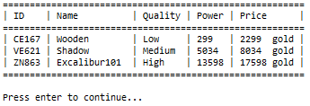

**Figure 4. View All Data**

**3. Delete Weapon (Menu 3)**

The third menu allows the user to **delete a weapon from the list**. The deleting process follow the following steps:

* + - * If there is no weapon data, **show message** “**There is no data..**”.

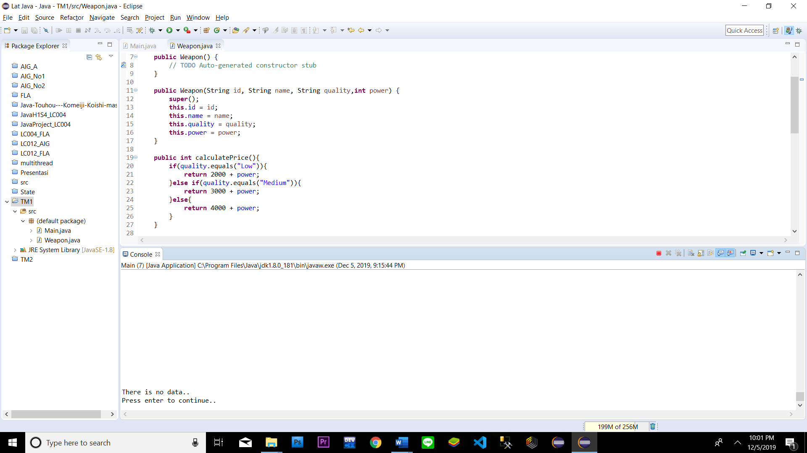

* + - * Otherwise, **Print all** the **weapon data** in the list.
      * Ask the user to **input Weapon ID to be deleted**.Validate the ID must be **Exists in List of Weapon**.
      * If the user **input 0** then the program will back to the **main menu**.

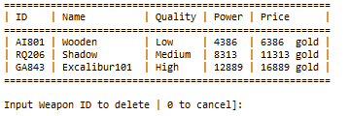

**Figure 5. Input Weapon ID (Delete)**

* + - * Otherwise, the program will **delete the selected weapon** from the list and **show message “Delete success..”**.

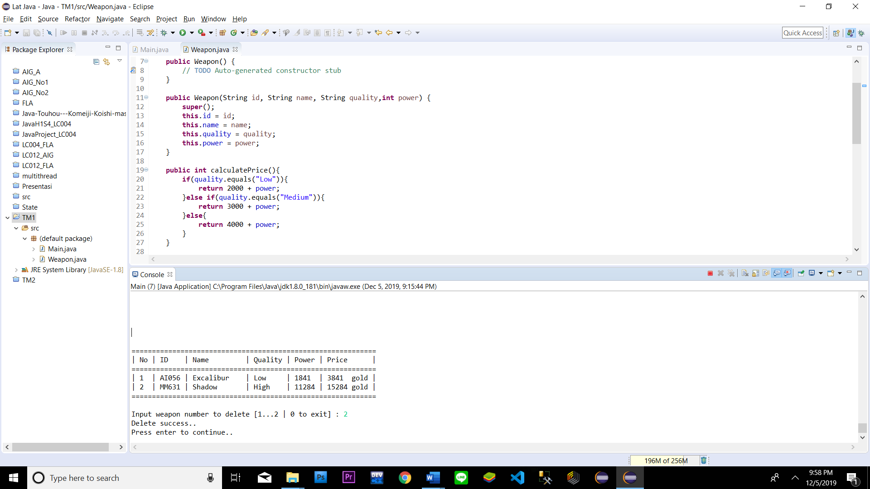

**Figure 6. Success Message**

* + - * After the weapon deletion has been **completed successfully**. **Update the data** inside **“Weapons.txt”** and **redirect the user** to the **main menu.**

**4. Exit (Menu 4)**

* + - * If the user chooses the fourth menu, the application will **print tick of time using a timer** and show **the user a message** that says: **“Thank you. Good Bye!”**.



**Figure 7. Exit Message**

**Must be collected:**

1. Java Project (Including NachOS and student’s code) compressed (.zip)